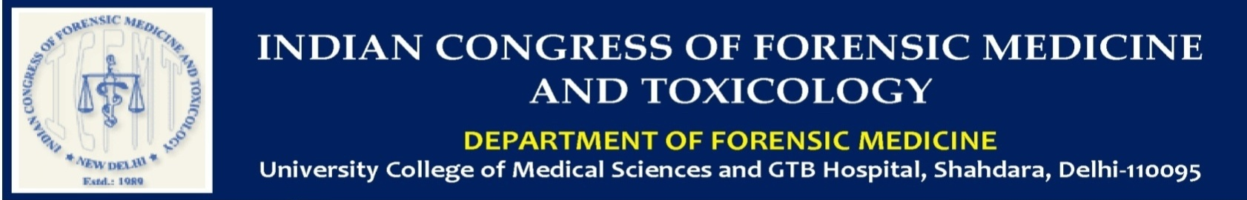
LIFE MEMBERSHIP FORM
1. Full Name (in capital letters): …………………….………………………………….……….….……………….
2. Gender: Male Female Other
3. Designation: ……………………………………………………………………………………………………..….
4. Department: ……………………………………………………………………………………..………………….
5. Contact No.: …………………………………………………………………………….…….....….... ……………
6. Institution:…………………………………………………………………………………….……… …………...
7. E-mail address (Write clearly since all further communication to participants will be through this email only) : ………………………………………………………………………………………………..……………………
8. Address-
Permanent Address
…………………………………………………………………………………………………………………………………………………………………………………………………………………………………………………………………………………………………………………………………………

Current Address
………………………………………………………………………………………………………………………………………………………………………………………………………………………………………………………………………………………………………………………………………………………………

9. Nationality : ……………………………………………………………………………………
10. Life Membership Fees : 5000/-
Payment to be made as per following details-
Modes of payment- Please tick in the correct box: NEFT RTGS Demand Draft
Payable to: ………………………………………….Account No: …………………………………….
Payable at: ………………Branch Code: …………………………….IFSC Code: ……………………
Total Amount (Rs.): ……………………… Bank Transaction ID: ………………...........................
Date of Transaction: ………………...... ... From (Bank Name with Branch): …………..………...

Note:
- Form will not be accepted without payment of life membership fee and transaction ID with date of transaction. There is no provision for refund of registration fee.
- In case of Demand Draft, please send the scanned copy of the Demand Draft along with completed Registration form through Email to the undersigned.
- Registration form will not be accepted without scanned copy of the RECEIPT OF MONEY TRANSACTIONS.
11. Achievement / Work in the Field of Forensic Medicine: ………………………………………………..
…………………………………………………………………………………………………………..
12. Any other Association Membership: Please mention ………………………………………………………..
……………………………………………………………………………………………………………………

Authorized Signatory

